Food to Door

**Students names:**

Reem Almualem 2190000429

Narjis Al-Jummaia 2190000716

Sarah Alghamdi 2200000185

**Instructors**

Dr. Thowiba Awad TA. Maha Alghamdi

Academic year 1442-2021

In this project a database has been created. Each entity has a relation that has some attributes, constraints and relationships.

This is the Customer relation with the attributes and some values about the customer:

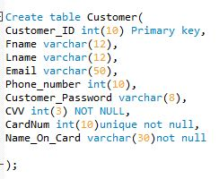

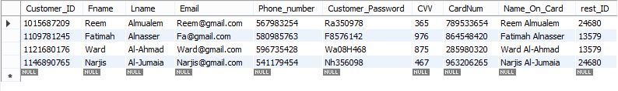  
an attribute has been added into Customer relation



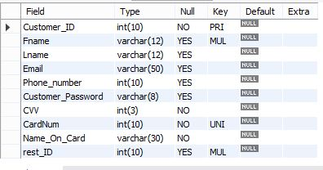Customer relation description

This is the Restaurants relation with the attributes and some values:

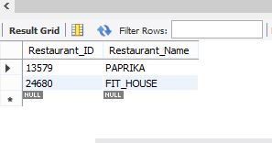

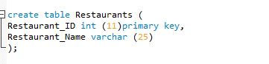

Restaurants relation description

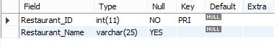

Since there are two restaurants, two menus have been created each Menu has and ID that identifies it. The menus are under the name Products . Here are the relation and the attributes for this entity:

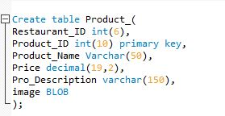

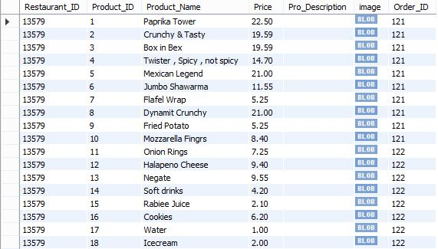

In this relation an attribute has been added as well as some values for that attributes.



Order relation description

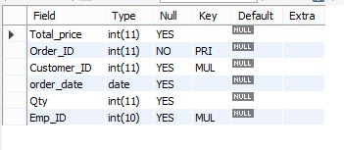

To enable the customer to place the order an Order entity has been created. This entity has some attributes that facilitates the ordering process:

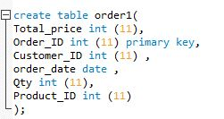

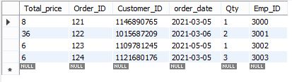

In this relation an attribute has been added as well as some values for this attribute.



Also an attribute has been removed



Product relation description

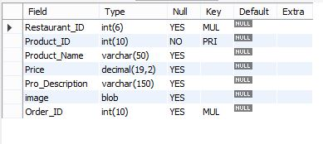

To enable the employees to deliver the order to the correct location in the college a Delivery entity has been created with some attributes:

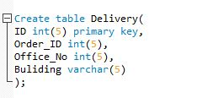

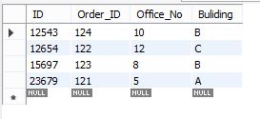

Delivery relation description

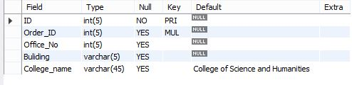

Last entity in the project is the Employee. The employee relation has some attributes as shown in the figure:

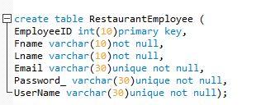

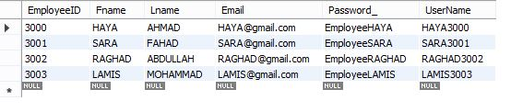

Employee relation description

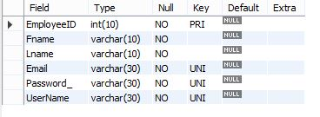

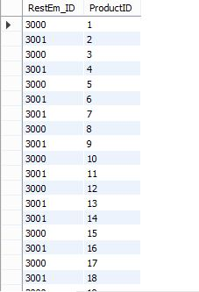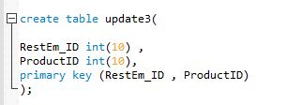Since Update relationship is M-N so a relation for this relationship has been created:

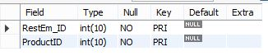Update relationship relation description

These are some constraints needed to make the relationships between the relations:

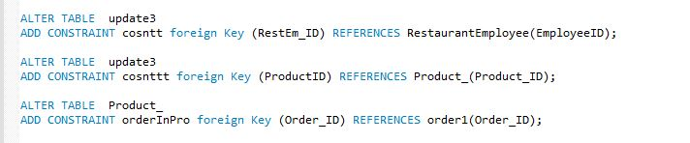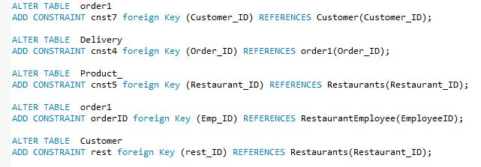

Default constraint has added for the name of the college attribute since this application only for College of Science and Humanities:

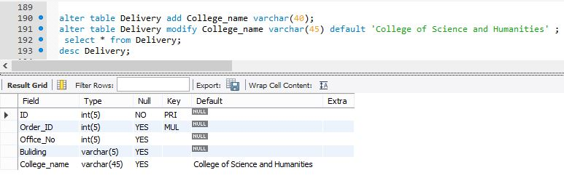

Check constraint has been added to check the name of the restaurant:



Retrieving the name of the product and the image of the product who have the price more than 20 SR:

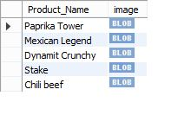

A view with the customer's first name whose name has letter "A" as a second letter and the total price of customer's order by sorting the names in ascending order:

 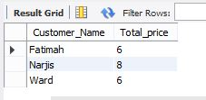

Retrieving the number of orders and ID, grouped by the building number of buildings who have more than one order:





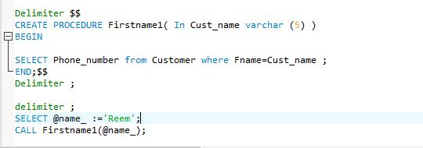A procedure that takes the first name of the customer and print the phone number of the customer:

This query prints total price, order ID and customer ID that has the highest average of the total price:

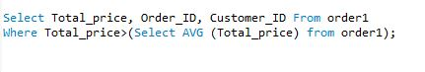

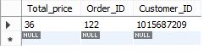  
This query print the email and employee ID for the employees who have less than Lamis ID

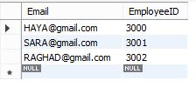

This nested query print the product name and price for products that their prices not greater than 20SR

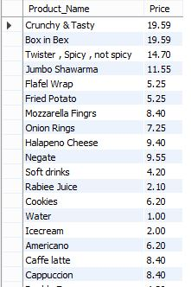

  
Joining some attributes from Order and delivery relations where the Building is "C":

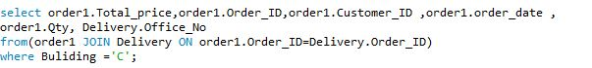

Creating an unique index for Customer table for Fname Lname where Fname= Ward and Lname= Al-Ahmad

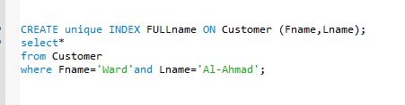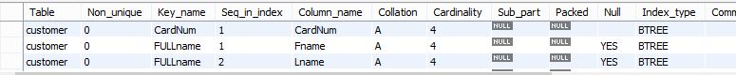

Creating a trigger that will update new Employee ID when adding a new name to the Employees

